Heroes of Waterloo

Philip White
Visitors to Prestwold Church will have seen the impressive monument to Sir Christopher Packe, woollen trader and Cromwellian Lord Mayor of London, who retired to his Cotes and Prestwold estates in 1660. The Prestwold line continued through the elder son, Christopher, and in the Church there is also a poignant memorial to Sir Christopher's great-great-grandson Major Robert Christopher Packe, who was killed leading a cavalry charge at the battle of Waterloo.

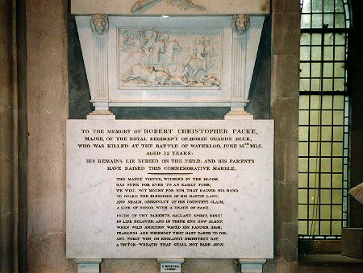
The memorial to Robert Christopher Packe in Prestwold church. Photograph by Philip White.

A supposed Anglo-Irish descendant of Sir Christopher, Major General Sir Denis Pack, also fought at Waterloo and this is an account of the separate paths the two men took to glory.

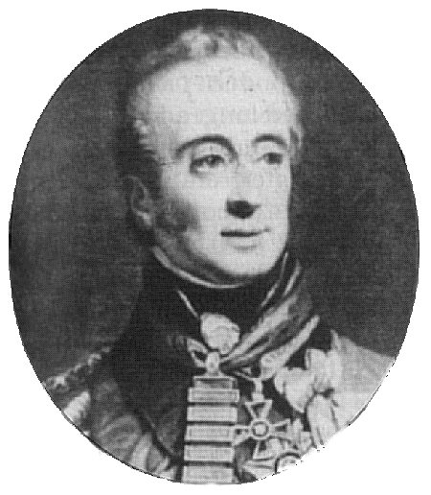
Sir Denis Pack. From a print by Sanders, reproduced from Who was Who in the Napoleonic Wars by Philip J. Haythornthwaite (published by Arms and Armour 1998) by kind permission of Weidenfeld and Nicolson Military.

In Robert Christopher Packe's day, Prestwold was a thriving village, boasting an inn and a church school. Robert would have learned early to ride and shoot. In a letter to his mother from Eton in 1798, aged 15, he wrote that he wished to join the army on leaving school and from the choices given to him by his father, he opted for a cavalry regiment. He joined the crack Royal Regiment of Horse Guards in 1800 as a Cornet, rising to Lieutenant after training and some service experience. There is no record of field service until the Peninsular War.
Meanwhile, 16-year-old Denis Pack joined the 14th Light Dragoons in Ireland, and after being cashiered for striking Captain Sir George Dunbar, he re-enlisted and had a meteoric rise through the ranks. In 1794, serving in Flanders, he carried a despatch into besieged Nieuwport, escaping by boat. He was made Lieutenant and, after action at Quiberon, his Dragoons defeated insurgents in Ireland. As a Captain commanding a troop he escorted the captured French General Humbert to Dublin. He was raised to Major of the 4th Royal Irish Dragoons in 1798, and two years later he became Lieutenant Colonel of the 71st Highland Light Infantry. In 1806, at the recapture of the Cape of Good Hope, he was wounded, and later suffered three wounds while fighting in South America. He was captured with General Beresford at Buenos Ayres but both escaped. Returning to Europe, he fought at Roleia and Vimiera and was with Sir John Moore in the rearguard action and evacuation from Corunna, Spain. He became ADC to the King. In 1810, following the Siege of Flushing, where he stormed and captured batteries held by a force five times his own, he served under Wellington in the Peninsular War against Napoleon's armies.
Around 1812, the Household Brigade, i.e. the 1st and 2nd Lifeguards and the Royal Horse Guards, also became involved in the Peninsular War. In March 1813, the Duke of Northumberland wrote from Alnwick Castle to Captain Robert Packe who was commanding a detachment of Royal Horse Guards at Thomar, and mentioned a squadron detached to Portugal. On 21st May 1813, he congratulated Major Packe in Lisbon on his promotion, saying he had hoped to recommend him for Lieutenant Colonel, but the regiment was only allowed two. In February 1814, Robert was awarded the Vittoria medal for gallantry during the battle, and Frederick, Duke of York, the Commander-in-Chief, sent his and the Prince Regent's congratulations. Writing home about Spain, Robert said, 'French General Clausel at Vittoria suffered heavy losses with 1,500/2,000 killed and taken prisoner, our men enjoying immense plunder, doubloons, dollars, French crowns. This is not cavalry country. Our horses are in cantonments, two lost by a stable roof falling in and poison. I was left with only one horse in Salamanca. I met up with Henry [his brother Lt-Col Henry Packe of the 1st Guards] at Salvatierra on 25th June 1813 after the fight of the Brigade'. In August 1814, back at Windsor Barracks after crossing from Calais following Napoleon's defeat and exile to Elba, he wrote to his sister Maria: 'Wellington and York are coming to see the regiment and give us dinner. I am busy discharging men and casting horses, then returning to Prestwold. I am sending 2 hogsheads of wine from Bordeaux for father'.
Denis Pack, commanding Portuguese troops, had been occupied at Busaco and blowing up Almeida's defences. In 1812, now a Brigadier General, he helped to capture Ciudad Rodrigo, later distinguishing himself at Salamanca and Burgos. Promoted to Major General in 1813, he fought at Vittoria, led a Division in the Pyrennees, Nivelle, Nive, Orthes and Toulouse, was wounded eight times, awarded the Peninsular Gold Star with seven clasps and was knighted. On Napoleon's escape from Elba, he took command of the Highland Brigade in Picton's Division. Accounts of a Brussels review describe 'fiery Sir Denis Pack' leading his kilted Highlanders, including the Royal Scots, the 42nd Royals and the 92nd Gordons, drawing cheers. He had a temper – a rhyme after his escape ran, 'The Devil break the gaoler's back that let thee loose sweet Denis Pack' – but he was very popular with his men, 'one of those who says "Come, my lads, and do this", and who goes before you to put his hand to the work'.
Both Robert Packe and Denis Pack were wounded opposing Napoleon's army at Quatre Bras outside Brussels on 16th June 1815.
The Highlanders, although severely mauled by Ney's cavalry and artillery, stood firm. Two days later at Waterloo, Denis Pack's brigade occupied left of centre near La Haye Sainte. Early on, they repulsed a massive attack by D'Erlon's 15,000 strong infantry. They were protected by the reverse slope and hedges, and although their Dutch-Belgian allies broke, they closed the gaps to the skirl of the pipes, with Denis Pack calling: '92nd everything has given way to you. Charge'.
Fortunately, at that moment, 2,000 heavy British cavalry of the Union and Household Brigades, led by Uxbridge, Ponsonby and Lord Edward Somerset, with Sir Robert Hill and Robert Packe heading their blue-tunicked Royal Horse Guards, hit the French hard, creating havoc, killing 2,000, taking 3,000 prisoners and two eagles. They charged too far and were badly cut up by French lancers and curassiers. Of the seven cavalry regiments, only the Royal Horse Guards – the Blues – maintained a semblance of order, and although barely 200 sabres, helped to bring off and protect the Household Brigade survivors on the way back. But they took severe casualties. Later Blücher's Prussians arrived to ensure Napoleon's defeat.
In a letter to Robert Packe on 24th June 1815, his mother said: 'Lord Wellington's despatch mentioned that many excellent officers had fallen and [she had] heard Robert Hill was wounded. Thank God you appear to be safe and command of the regiment will probably devolve on you. We have a new horse for you 55 guineas. On the estate the corn is doing well, the keepers say there are plenty of pheasants and partridges and the grounds are like a rabbit warren. Father is well except for gout'.
Sadly, Robert's promising military future was not to be. According to Farrington's Diary, 8th July 1815, Mr W Hanbury called on Robert's parents to tell them he had been killed in the charge of French currassiers at Waterloo. A sword was run into his body and he had a cut to the head. He had died instantly, having had two horses killed under him. In And They Rode On, Michael Mann, Dean of Windsor, wrote that R.C.Packe was killed when charging French currassiers because their cavalry swords were two inches longer than the British ones, the longer reach being aimed at the throat, and the Blues had no breastplates. Robert Christopher Packe was buried on the battlefield. The officers of the regiment in which he served for over fifteen years erected a memorial in the north choir aisle of St George's Chapel, Windsor 'in testimony of their high veneration of his distinguished military merit and regret for the loss of a companion endeared to them by his amiable manner and virtue'. His parents erected the monument in the church at Prestwold. On it is a sculptured battle scene and an epic poem describing his courage.
In 1816, Sir Denis Pack married Lady Elizabeth Beresford, the daughter of the 1st Marquess of Waterford. They had four children. Sir Denis became Colonel of the 84th Regiment of Foot and Lieutenant Governor of Plymouth. He died in 1823 and was buried in St Canice's Cathedral, Kilkenny. His eldest son, Arthur Reynell Pack, godson of the Duke of Wellington, emulated his father's military career and became a Lieutenant Colonel, his youngest son was heir to Field Marshall Lord Beresford and changed his name to Denis Pack Beresford.

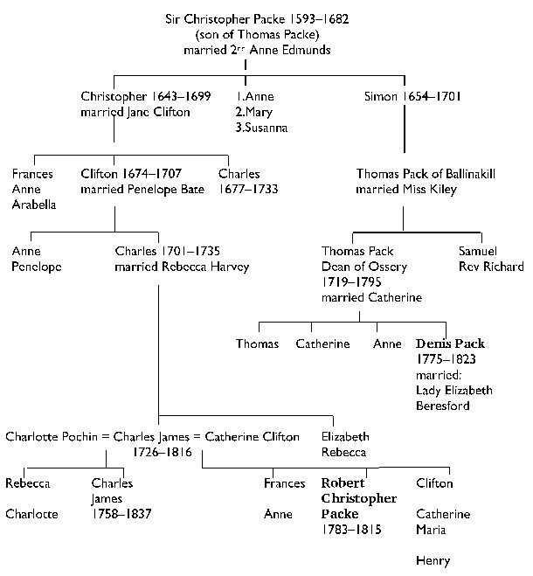
Family tradition among the Packs of Kilkenny is that their branch is descended from Lieutenant Colonel Simon Pack(e), the youngest son of Sir Christopher Packe, who settled in the Queens County. Simon Pack fought at the Battle of the Boyne and Limerick, and was stationed at Dundalk. The above pedigree was drawn by Frances Bell, a family genealogist. Joy Cross's book "Prestwold Hall to Branksome Tower" profiles Sir Denis and shows a similar, though less detailed, pedigree.
Sir Christopher's son, Simon, died in 1701 and was interred at Prestwold. A possible explanation for his presence in Ireland may be connected with the fact that as Governor of the Merchant Adventurers Company, Sir Christopher Packe was granted land in East Meath.
George Hussey Packe, the nineteen year old son of Robert Packe's half-brother Charles James Jnr, fought at Waterloo as a Cornet in the 13th Light Dragoons and was wounded. He later inherited the Prestwold estates.

Sources
Prestwold Hall to Branksome Tower, Joy Cross, Bournemouth Local Studies' Publications 1993
Who was Who in the Napoleonic Wars, Philip J. Haythornthwaite, Arms and Armour 1998
Personal Narrative of a Private Soldier in the 42nd Highlanders, anon, London 1821
Memoirs of Major General Denis Pack, D. Pack-Beresford, Dublin 1908
An Infamous Army, Georgette Heyer, Ballantine Publishing Group 1977
Galloping at Everything – Appraisal of British Cavalry in Peninusular and Waterloo, I. Fletcher, Spellmount Publishers 1999
Papers relating to the Packe family of Prestwold in the Record Office of Leicester, Leicestershire and Rutland
Family papers in the possession of Frances Bell, descendant of Arthur Reynell Pack.

Originally published in the 2000 Years of the Wolds 2003.

Copyright the author

next article

WHO home page

