Sir Denis Pack
  Birth: | Oct. 7, 1774  Kilkenny  County Kilkenny, Ireland
  Death: | Jul. 24, 1823  London  Greater London, England
  Family links:
  Parents:
  Thomas Pack (1719 - 1795)
  Catherine Sullivan Pack (____ - 1801)
  Spouse:
  Elizabeth Louisa Beresford Reynell (1783 - 1856)*
  Children:
  Arthur John Reynell-Pack (1817 - 1860)*
  Siblings:
  Anne Pack (____ - 1795)*
  Thomas Pack (1769 - 1786)*
  Denis Pack (1774 - 1823)
  *Calculated relationship
  Inscription:
  Near this place are interred the mortal remains of MAJOR GENERAL SIR DENIS PACK, Knight Commander of the Most Hon. Military Order of the Bath and of the Portuguese Military Order of the Tower and Sword, Knight of the Imperial Russian Order of Wladimer, and of the Imperial Austrian Order of Maria Theresa; Colonel of the 84th Reg't of Foot, and Lieutenant Governor of Plymouth; who terminated a life devoted to the service of his King and Country on the 24th Day of July 1823, aged forty eight years.
  The name of this distinguished officer is associated with almost every brilliant achievement of the British Army during the eventful period of Continental warfare between the year 1791 in which he entered His Majesty's service, and the year 1823, in which he ended his honorable career. Throughout the campaigns in Flanders in 1794, and 1795, he served in the 14th Regiment of Light Dragoons; at the capture of the Cape of Good Hope in 1806, and on the arduous and active campaign which immediately followed in South America, he commanded the 71st Regiment of Highlanders in a manner which reflected the highest credit on his military skill and valour. At the head of the same Corps in 1808, he acquired fresh reputation in the battles of Roleia and Vimiera; and in the following year in the battle of Corunna. In 1809 he accompanied the expedition to Walcheren, and signalized himself by his zeal and intrepidity at the siege of Flushing. He was subsequently engaged at the head either of a brigade, or of a division of the army in every general action and remarkable siege which took place during the successful war in the Peninsula under the conduct of the great Duke of Wellington. He finally commanded a bridgade in the action of Quatre Bras and again in the ever memorable and decisive battle of Waterloo. For these important services in which he was nine times severely wounded, he obtained at the recommendation of his illustrious chief from the foreign Potentates in alliance with Great Britain the honorable titles of distinction above mentioned, and from his own Sovereign, besides the Order of the Bath and a medal in commemoration of the battle of Waterloo, a gold cross with seven clasps, on which are inscribed the following names of the battles and sieges wherein he bore a conspicuous part viz. Roleia, Corunna, Busaco, Cuidad Roderigo, Salamanca, Vittoria, Pyrenees, Nivelle, Nive, Orthes, Toulouse. Upon five different occasions he had also the honour to receive the thanks of both Houses of Parliament. On the 3d February 1813 for his conduct at Salamanca; on the 10th February 1813 for his conduct at Ciudad Roderigo; on the 8th November 1813 for his conduct at Vittoria; on the 24th March 1814 for his conduct at Orthes; on the 23d June 1815 for his conduct at Waterloo. Whilst these his merits as an officer ensure for him a place in the records of his grateful country amongst those heroes who have bravely fought her battles and advanced her military glory, his virtues as a man, which were securely founded upon Christian piety, are attested by the esteem of his companions in arms and by the love of all who were intimately connected with him.
  This monument is erected by his widow, THE LADY ELIZABETH PACK, daughter of George de la Poer Marquess of Waterford, as a just tribute of respect to the memory of one of His Majesty's most deserving soldiers and subjects and in testimony of her own affection.
  Burial:
  Saint Canices Cemetery
  Kilkenny
  County Kilkenny, Ireland
  Created by: Peggy
  Record added: Nov 23, 2009
  Find A Grave Memorial# 44700709
  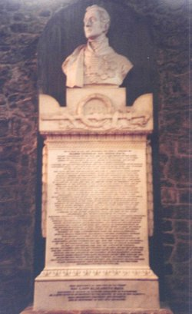
  Added by: Peggy
  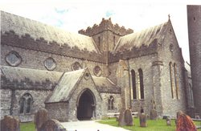
  Cemetery Photo
  Added by: Peggy

