**[Irish Martello Towers](https://irishmartellotowers.wordpress.com/" \o "Irish Martello Towers)**

*an exploration and guide of the Martello towers in Ireland*

[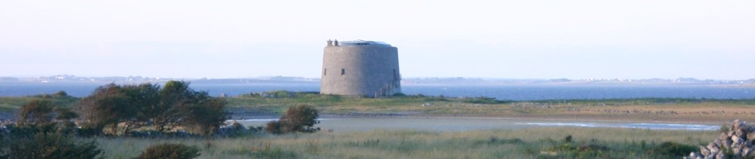](https://irishmartellotowers.wordpress.com/)

[Skip to content](https://irishmartellotowers.wordpress.com/north-of-irelandlough-foyle-lough-swilly/#content)

* [Home](https://irishmartellotowers.wordpress.com/)
* [1:Introduction](https://irishmartellotowers.wordpress.com/introduction/)
* [1a: North Dublin Coast](https://irishmartellotowers.wordpress.com/locations/)
* [2 : South Dublin Coast](https://irishmartellotowers.wordpress.com/locations-south-dublin/)
* [3 : South East Coast](https://irishmartellotowers.wordpress.com/locations-east-and-south-coast/)
* [4: South Coast: Cork-Kerry](https://irishmartellotowers.wordpress.com/location-south-coast/)
* [5:Shannon Estuary/Clare-Galway](https://irishmartellotowers.wordpress.com/locationswest-coastclare-galway/)
* [6:Shannonbridge-Banagher Crossings](https://irishmartellotowers.wordpress.com/shannonbridge-banagher/)
* [7:North of Ireland:Lough Foyle-Lough Swilly](https://irishmartellotowers.wordpress.com/north-of-irelandlough-foyle-lough-swilly/)
* [8. Other Countries](https://irishmartellotowers.wordpress.com/other-countries/)
* [Navigation note](https://irishmartellotowers.wordpress.com/navigation-note/)
* [Publications/References](https://irishmartellotowers.wordpress.com/publicationsreferences/)
* [Tower features/Credits/Famous World Forts](https://irishmartellotowers.wordpress.com/creditsfamous-fortifications/)

**7:North of Ireland:Lough Foyle-Lough Swilly**

**Lough Swilly Lough Foyle**

At the beginning of the nineteenth century despite past failures of two French invasions and the suppression of the 1798 Rebellion, the British were all the more convinced that another successful attempt would have widespread support of the population, more so in the north of the country where the movement was strongest and where deep water existed to facilitate the landing by a large fleet.  
A similar plan was adopted at these locations to those at Cork Harbour, Bantry Bay and Shannon Estuary: the placements of fortifications on both sides of the Loughs so that any invading force would have to negotiate cross fire from both sides.  
At Lough Swilly, signal towers were positioned at Fanad Head and Malin Head with Forts at Dunree, Neids Point, Leannan and Dawn Fort on Inch Island. On the west side a large fort was constructed at Knockalla, a martello tower with supporting battery at Muckamish and a battery at Rathmullen.

[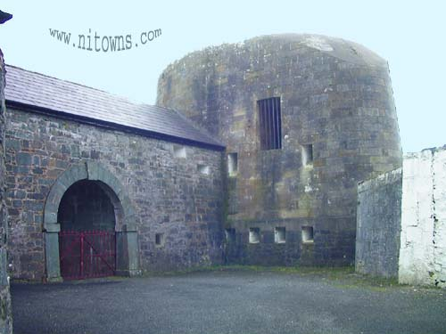](https://irishmartellotowers.files.wordpress.com/2012/12/gccasarch2_a.jpg) **North of Ireland Martello Towers  
The Tower at Greencastle has been restored and it is now used as a licensed Bar, restaurant and Beer garden. The Tower at Magilligan was also restored and due to its location is not being used for any purpose and special permissions would have to be made to visit .  
Lough Foyle aand Lough Swilly**

[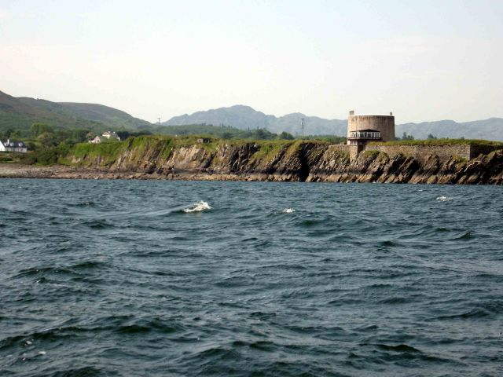](https://irishmartellotowers.files.wordpress.com/2012/12/fig87p79.jpg)  
**Macamish Martello Tower, Lough Swilly.**  
[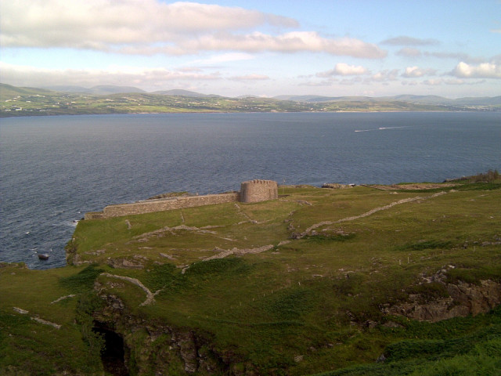](https://irishmartellotowers.files.wordpress.com/2012/12/fig85p78.jpg)  
**Knockalla Fort, Lough Swilly, County Donegal,Photo Peter Dillon**  
Fears of the possibility of invasion by the French by way of the north of the Country was carefully considered by the British and it was decided to erect martello towers and a network signal towers and forts at Lough Swilly and Lough Foyle on the northern coast of Co.Donegal. The Signal towers were located at the point of entry to Lough Swilly on the westward side at Fanad and at Malin Beg near the most northern part of Ireland. Both locations offered sheltered harbours and deep waters.  
On the westward side of Lough Swilly a Martello Tower and Battery was constructed at Muckamish supported by a fort at Knockalla to the North and Rathmullen Battery to the South.  
Inter spaced on the opposite side of Lough Swilly on the Inishowen Peninsula a large fort was built at Dunree Point and Batteries at Neds Point, Buncrana, Saltpan Hill and the Dawn Fort on Inch Island. A large fort and battery was built at Leenan near Ramelton, only the ruins remain but the Battery is in good condition. The fortifications were intended to stop any landing by the French at Letterkenny.

[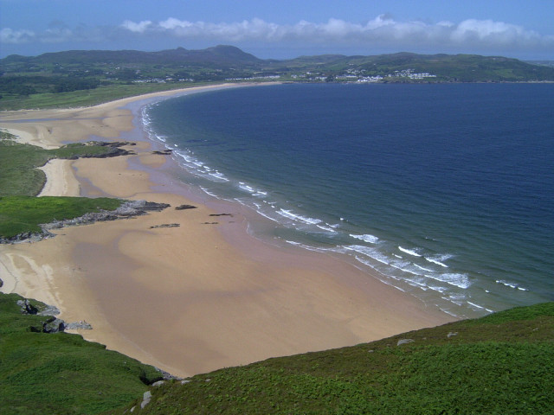](https://irishmartellotowers.files.wordpress.com/2012/12/fig84p77.jpg)  
**Fanad Beach County Donegal. Photo courtesy Peter Dillon**

Lough Foyle  
Two Martello towers were positioned covering the entrance to Lough Foyle from the sea, on the west side of the Lough at Greencastle and almost opposite on the east side at Magilligan Point. The Magilligan Tower was built towards the end of the wars in 1812 and is one of the most northerly of all around the coasts of Ireland. The tower was built on top of a spring to ensure sufficient water supply in the event of a siege.  
This tower has now been restored to its former glory .. at one time off-limits to visitors and tourists as it is located beside Magilligan Jail and an army firing range. A new pier nearby will cater for a new ferry that will save people from Limavady the 35 mile round-trip when visiting the jail or wishing to view the Martello Tower.  
<http://roevalley.com/newsbrowser/historical/martello.htm>

[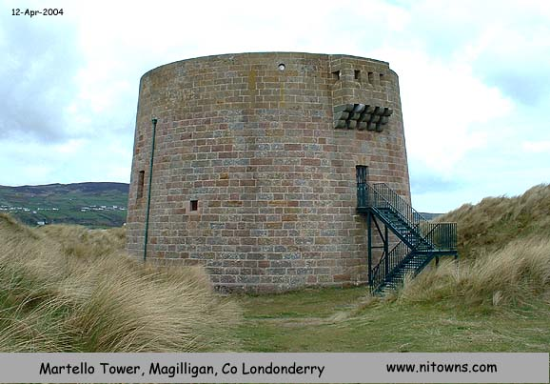](https://irishmartellotowers.files.wordpress.com/2012/12/fig88p80.jpg)

Dunree Fort  
Dunree Fort is now restored and is regarded as one of the finest examples of fortifications in Europe next to Fort Charles in Cork harbour. It opened as a military museum in 1986 and gained new prominence during World War 2. Built on a cliff, the fort commands panoramic views of Lough Swilly. The museum displays the important role played by the fort protecting the safe anchorage for the British over the past two hundred years since its initial role was to protect against an invasion by Napoleon’s fleet. Neds Point Fort remodelled in 1896 is also open to the public. Both forts are north of Buncrana, where according to local lore it was to Buncrana Castle that Wolfe Tone, the ‘father of Irish nationalism’ was taken after he was captured on board the French warship Hoche in 1798 at Lough Swilly. Some of the Hoche guns were taken to Carrickfergus Castle and the ship was later repaired and renamed HMS Donegal and later fought under Nelson’s colours at the Battle of Trafalgar. Another fort was reported to be opposite Dunree at Portsalon but no information can be found.  
**Greencastle and Magilligan.**Two martello towers were positioned at the point of entry to Lough Foyle. At Greencastle on the Inishowen Peninsula in County Donegal and opposite at Magilligan Point in County Derry. There is also a jail at Magilligan and surrounding lands are used as an Army practice firing range, making it difficult for access. A ferry now runs between Greencastle and Magilligan and is very much welcomed by the local people: eliminating approx.35 miles off the distance by road.  
Both towers were armed with small bore cannon and their primary purpose was to protect was to defend against any invasion attempt by the French fleet and the capture of the City of Derry. After the Battle of Trafalgar in 1805 the Martello tower at Greencastle was extended to a fort and completed in 1812. The new building consisted of an upper and lower fort armed with cannon and was later used as a barracks when over eighty men were stationed there until the end of the nineteenth century.. The increased numbers were billeted there due to the unrest prevailing in the North of Ireland at that time. The Martello tower at Magilligan Point has now been refurbished by the National Trust and regarded as one of the finest examples of Martello towers in Ireland and England.

[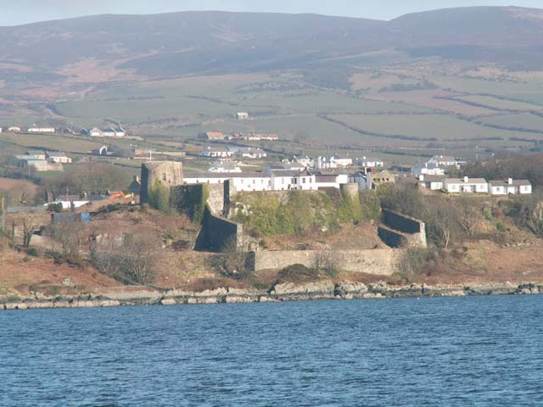](https://irishmartellotowers.files.wordpress.com/2012/12/fig90p82.jpg)

**View of Greencastle Martello Tower and Barracks taken from Ferry**.