French Hill Monument
By Brían Hoban
FRENCHILL, CASTLEBAR, COUNTY MAYO
Site of engagement between the Franco-Irish forces and English forces on 26th August 1798 following the defeat of English forces at Castlebar & the Races of Castlebar.
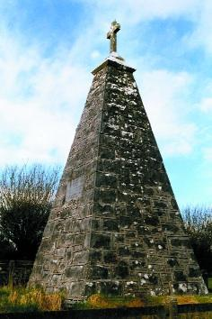

Following the rout of the Redcoats at Castlebar a small party under Bartholomew Teeling pursued Lord Roden's rear guard. Their flag of truce was attacked and five French Cavalry were brutally murdered. The place where they fell is known as Frenchill. A magnificent pyramid like monument at Frenchill, 3 miles south of Castlebar, marks the spot where a party of French Cavalry, travelling under a flag of truce, were killed by English forces.
Two Local men James Daly and Patrick Nally erected a monument to their memory in 1876. The Monument bears the inscription:

"In grateful remembrance of the gallant French soldiers who died fighting for the freedom of Ireland on 27th August 1798. They shall be remembered forever".
1898 EVENT
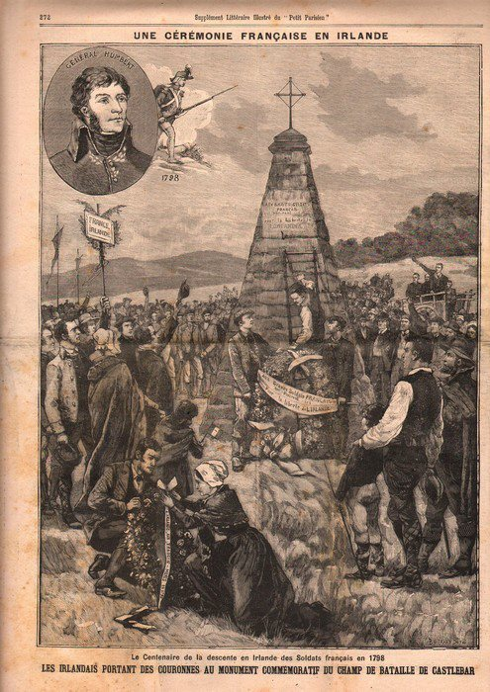

William Rooney was one of the main protagonists in establishing the National Commemoration to celebrate the centennial of the 1798 rebellion. Only one month after its inception nationalists in Mayo formed the "Castlebar Central and Barony of Carra '98 Centenary Association with James Daly appointed as president of the Connaught '98 Centenary Council.
On the 9th January 1898 a commemoration, which was presided over by James Daly, was held at Frenchill, near Castlebar. This was attended by Maud Gonne Mac Bride and addressed by James Rooney, who gave an address in the Irish language. James Rooney was regarded as the "Thomas Davis" of the 1890's and was much in demand at patriotic gatherings.
James Daly pointed out that the event was both about remembering dead patriots and undertaking "to abide by the principles of the men of '98 until their country was free again and took its place among the nations of the earth."

