Ballinamuck Visitor Centre
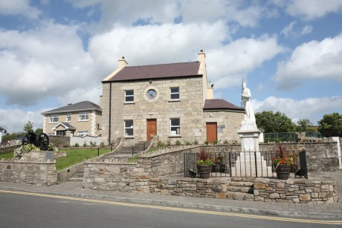
History & Info
The Ballinamuck Visitor Centre, formerly the historic Royal Irish Constabulary barracks, is located in the picturesque village of Ballinamuck, North County Longford. Built in 1846, the barracks originally had two towers which were destroyed and burned by the IRA in June 1920, during the War of Independence. It was due to the continuous insurrection and revolutionary nature of the people of North Longford that the barracks was erected in the first instance. In 1948 the building was restored as a memorial hall, but without the two towers, and in July 1999 it was officially opened by President Mary McAlesse. The centre houses a fascinating and lively exhibition which details the famous Battle of Ballinamuck which took place in 1798.
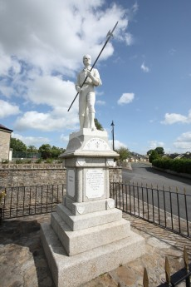
The Battle of Ballinamuck
This battle marked the ending of the 1798 Rising of the Irish against the British. It was in Ballinamuck that the combined French and Irish armies were defeated by the British forces under the command of General Cornwallis. The French contingent was led by General Humbert of Saint Nabord. After the battle was lost, and Humbert surrendered, the French survivors were sent home but the Irish survivors were hunted down and mercilessly executed in a spot now called ‘Bullys Acre’ in nearby Ballinalee village. Visitors to the centre can learn about the heroic stand made by ’Gunner Magee’ against the British and the atrocities of the ‘Walking Gallows’. The fateful events of the 8th September 1798 are vividly presented, with eyewitness accounts from local people and officers of the opposing armies. The exhibition explains the social and political background to the historic battle, as well as the national and international significance of the collision of forces around this county Longford village.
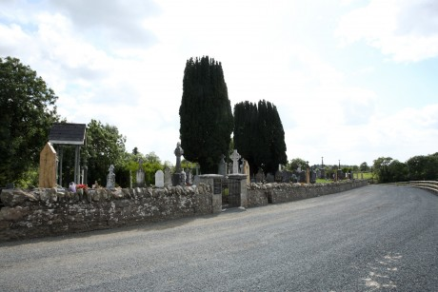
Battle Trails & Graves
After informing oneself on the impressive history of the area you may tread the ground where the battle took place, following the trails and visiting the battle sites. Thereafter you can visit the graves of those that paid the ultimate price in their bid for Irish Independance – from the ‘Croppies Graves’ to their leader General Blakes resting place in nearby Tubberpatrick Cemetery.
A recent article by travel writer Leon O Cáthsaigh appeared in the popular magazine ‘Ireland of the Welcomes’. His cycle tour of the Midlands area included a visit to County Longford and the village of Ballinamuck, www.irelandofthewelcomes.com
Opening hours for the Ballinamuck Visitor Centre vary according to the time of year. For current opening times and booking information for groups please contact: Morris Murphy 00353 (0)87 – 2055462 or Paddy Howe 00353(0)87 -9613312
Nearby Edenmore Bog Walk is a Failte Ireland National Looped Walk and further details can be found on the Discover Ireland website www.discoverireland.ie
Further information on the ‘Ballinamuck Heritage Centre’ and ‘The Battle of Ballinamuck’ can be found on the ‘Explore Longford’ App available for download for both Apple iOS and Android Devices:
Android Store: http://bit.ly/1gMKZYY Apple Store: http://bit.ly/1n104Kk

