Last Invasion 1798
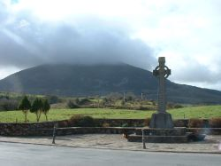
The French, under General Humbert landed in Kilcummin, close to Killala, on August 22nd 1798. They marched with the Irish Forces on Ballina, through Crossmolina, and camped on the Fairgreen in Lahardane in the parish of Addergoole, on the advice of Fr Andrew Conroy Parish Priest of Addergoole.
In the early hours of the morning they made their way with three cannon up the Gap Road to take the English force by surprise. The first part of this engagement took place on Sion Hill, close to the Sacred Heart Hospital in Castlebar.
The English troops were driven back, and eventually down Staball Hill over the bridge at the bottom, up and out of the town. The plaque on the bridge commemorates this engagement. Along the route several graves now lay forgotten.
Following this victory, the "Republic of Connaught" was proclaimed in Castlebar, and John Moore of Moore Hall was appointed its president. The new republic lasted less than a month.
Fr Andrew Conroy was hung on the Mall in Castlebar by the British Forces. His body was taken down by his parishioners and brought back to Addergoole, where it is believed to be buried in the old abbey.
Extract from the 'Rathkell National School Centenary Book 2007'
Click here to read more about Addergoole's role and Fr Conroy's in the French invasion of Ireland 1798

